Piezoelectric Pressure Sensing Shoe Insole

Team 47: Gerald Kozel and Alan Lee

ECE 445 Project Proposal

TA: Kyle Michal

**1. Introduction**

**1.1 Objective**

Our goal is to create a device that can provide actionable health information to a health care provider without interfering with daily life. Specifically, we decided to focus on gathering quantitative foot pressure distribution data in a way that is clinically useful for evaluating various foot or posture pathologies. How we will achieve this is by building a piezoelectric powered insole which is embedded with pressure sensors that is connected to a microcontroller. This microcontroller communicates via Wi-Fi with a phone application which processes the data into a format which displays the user’s foot pressure distribution over a period of time.

**1.2 Background**

Today, pressure mapping is mostly limited to lab analysis, kiosks, and existing commercial insoles. Both the kiosks and other insoles such as the DigitSole ([www.digitsole.com](http://www.digitsole.com)) provide pressure distribution data but does not facilitate the clinical application of said data. Rather, these focus on selling orthopedic insoles or providing runners with feedback in their techniques. TekScan, a producer of foot pressure sensing devices, offers a similar insole device called F-Scan. This solution is quoted at a price of $6,995 plus $35 per insole [1]. This is much more expensive than our planned solution, allowing us to sell the device to a much larger base of consumers for personal use.

**1.3 High Level Requirements**

* Sensor feeds a continuous stream of dynamic active foot pressure data. Here we will quantify this in a threshold of Pascals the sensors can stream the data for.
  + F = Mass * acceleration = Pascals * Area
  + ~950 newtons = 95kg * 9.8 m/s^2 = 0.01 m^2 * Pascals.  Pascals = 95000 = 95 kPascals
* Insole should be able to run from full charge for at least 8 hours in normal operation (without considering piezoelectric charging capabilities).
* Piezo electrics should offer significant energy savings (5-10%).

**2. Design**

**2.1 Block Diagram & Physical Design**

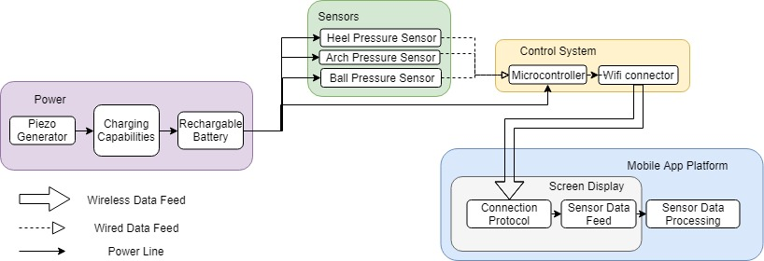

Physical diagram showing locations of sensors within the insole:

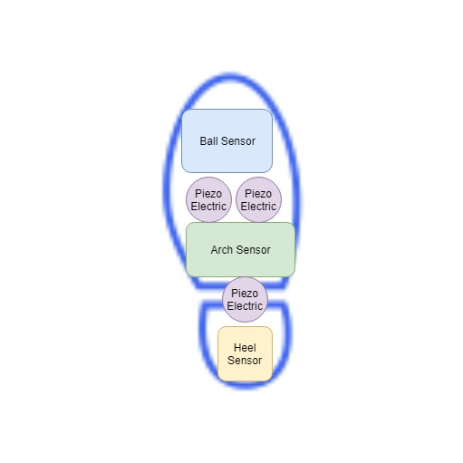

**2.2 Functional Overview**

There are four major modules in our planned physical design for a device. First is power, which includes our Lithium Ion battery and piezoelectric sensors. These connect to each other to enable charging capabilities as the user walks. This module primarily provides power to our sensor block where three pressure sensors are aligned on the sole, arch, and ball of the foot. Both the sensor block and the power block connect to our control system block, which includes a microcontroller and Wi-Fi connector/antenna for receiving and sending the data to the app. Our app takes the sensor data and processes it into a feed for display on the screen.

**2.3 Block-level Requirement**

**2.3.1 Power Supply**

*Piezoelectric Sensors*

These Sensors will provide supplemental power to charge the battery in use from the user stepping on them.

Requirement:

* Must provide total >8-10 mA between 3.3-4V during normal walking operation.

*Charging Capabilities*

This module handles both typical charging operation along with integrating the energy generated from the piezoelectric sensor.

Requirement:

* Must convert AC to DC (bridge rectifier) and utilize a capacitor to store charge.

*Rechargeable Li-ion Battery*

Our battery will operate at 3.6-4.2V and will power the majority of our design.

Requirement:

* Must store enough charge to provide ~160mA at 3.6-4.2V for 8 hours without factoring in the contribution from the piezo electrics.

**2.3.2 Sensors**

*Heel, Arch, and Ball Pressure Sensors*

These pressure sensors will dynamically feed its foot pressure data to the mobile app at various parts of the foot.

Requirements:

* Must Be able to sense pressure up to 95k pascals
* Must be powered by a 3.6v +- 15% power supply for 8 hours.

**2.3.3 Control System**

*Microcontroller*

The microcontroller handles the three pressure sensor feeds. It will intake these inputs and utilize the Wi-Fi Connector to stream the data to the Mobile App Platform.

Requirements:

* Must be powered by a 3.6v +- 15%  power supply for 8 hours
* Must be able to intake the sensor data inputs
* Must be able to utilize Wi-Fi connector
* Must be able to stream data to the mobile app platform module

*Wi-Fi Connector*

The Wi-Fi connector will be the component that allows the microcontroller to communicate with the mobile app platform.

Requirements:

* Must be compatible with the microcontroller and be powered by it
* Must be able to connect to mobile app platform with suitable bandwidth and latency for dynamic sensor data stream

**2.3.4 Mobile App Platform**

The mobile app platform will serve as the main user interface for the patient/user. It will be comprised of a mobile app screen that will capture the sensor feeds and visualize it into an aggregated pressure map of the user’s foot.

Requirements:

* Mobile app will be written on Android OS
* Mobile app will have a foot display for how much pressure has been put onto that point over time
* Mobile app must have connection to microcontroller on shoe to have data stream input

**2.4 Risk Analysis**

The Control System will pose the greatest challenge in the successful completion of this project. We must ensure that the microcontroller is compatible with the Wi-Fi connector. The Wi-Fi connector must have an adequate bandwidth and latency for a smooth stream of data from the connectors. It must also communicate to the mobile device which will be separated by a few feet (length of a person). The wiring of the microcontroller will also pose a challenge. Design on how it will be wired for power and sensor feed will be crucial to not obstruct the users walking while still having reliable wired connections.

**3. Ethics & Safety**

As with many projects, there are a few possible safety hazards involved. Our lithium-ion battery rechargeable battery which powers the device has a possibility to explode. This usually occurs in the case of a short circuit, where all of the energy within the battery is released at once. Short circuits like this can happen when the plastic separator fails between the anode and cathode, allowing them to physically touch [2]. Over-charging and high temperatures must be avoided at all costs and must be tested for while building the charging module of our project.

Our project gathers and processes potential Protected Health Information (PHI), which is requires us to ensure confidentiality, integrity, and availability of said data [3]. We would not include diagnosis within the app to avoid violating #3 in the IEEE code of ethics by potentially misdiagnosing a user. Primarily the data would be in the hands of a medical doctor who could utilize it accurately.

**4. References**

[1] Open Lab, ‘Wearable Weight Sensing and Feedback Device’. [Online]. Available: <http://www.openlab.psu.edu/wp-content/uploads/2014/04/Garneau_Wearable_Weight_Sensing_and_Feedback.pdf>. [Accessed: 6-Feb-2019].

[2] Battery University, ‘Safety Concerns with Li-ion Battery’. [Online]. Available: <https://batteryuniversity.com/learn/article/safety_concerns_with_li_ion>. [Accessed 6-Feb-2019].

[3] HIPAA Journal, ‘What is Protected Health Information?’. [Online]. Available: <https://www.hipaajournal.com/what-is-protected-health-information/>. [Accessed: 6-Feb-2019].